The Queen Mary Practice
South Woodford Health Centre
114 High Road
London, E18 2QS
Tel: 020 8491 3303

Coronavirus

Find out what you can do if you’re struggling because of coronavirus (COVID-19) - GOV.UK
By clicking on the link below, you will be able to find out what help you can get if you’re affected by coronavirus. You can use it for yourself or someone else. You can find information about:
- feeling unsafe
- going in to work
- paying bills or being unemployed
- getting food
- having somewhere to live
- mental health and wellbeing

Click here for the latest government support available during the Covid-19 pandemic

Coronavirus (Covid-19): An Easy Read Guide

Contact NHS 111 online here

Covid-19 household isolation advice in English, عربى, বাংলা, 普通话, français, ગુજરાતી, Polskie, ਪੰਜਾਬੀ, اردو

Guidance for Parents

Please click here for information

Ramadhan during Coronavirus Pandemic

We want to ensure our patients have the most up to date information during Ramadhan. Please click here for detailed information.

Get an isolation note
Use this service if you need a note for your employer because you have to stay at home because of coronavirus https://111.nhs.uk/isolation-note/

High Risk of COVID-19 Letter for employer
if you are in a high risk group and need to provide your employer with a letter regarding your high risk status please use this Letter to Employer which you will need to complete.
Redbridge Council Update
Redbridge Council have produced an update for Redbridge residents which you can find here. It includes information about the “Redbridge joins together” local community group, and the new well-being service they are establishing to support those at highest risk.
You can also access information for Redbridge Coronavirus information hub here (this link will open in a new window - popups must be allowed)
New NHS text service launched
A new service was launched on Saturday where new patients who register their Covid-19 symptoms and contact details with the 111 online service will receive daily texts from the NHS. The messages will check how people are and ensure that those who need help to get them through the isolation period receive it. The text messages will be sent as a reassurance to those who contact NHS 111 online, complete the assessment, and leave basic information such as their age, mobile number and when their symptoms started.

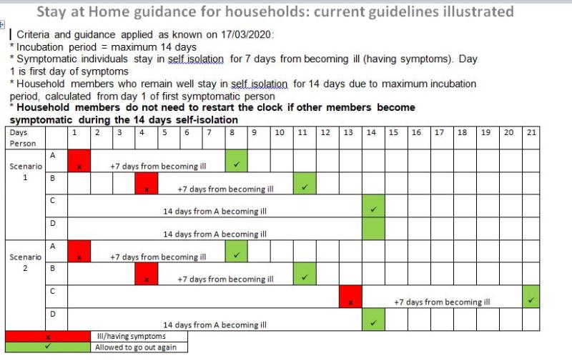
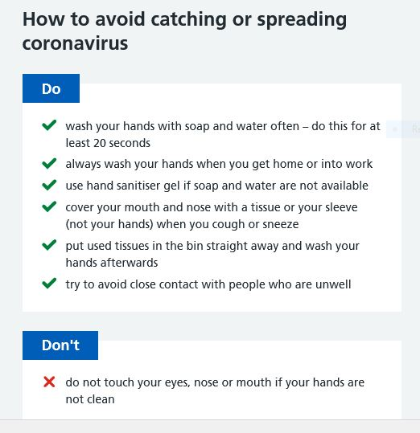
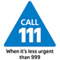| Edit | Staff Home | Sit

